**Experiment -1.1**

**Student Name: Km Ayushi UID:22BDO10055**

**Branch: CSE(DevOps) Section/Group-22BCD-1(B)**

**Semester: 4th Date of Performance:13/01/24**

**Subject Name- Git and GitHub Subject Code:22CSH-2931.**

**1.Aim/Overview of the practical:** Creating branches with GitHub.

**2. Task to be done:** Creating branches with GitHub and on Git Bash.

**3. Apparatus(For applied/experimental sciences/materials based labs):**Software used are git hub and git bash

**4.Steps for experiment/practical:**

1.Open your github and go to repository.

2. Add new file in that named “file1” , and after this just write the code.

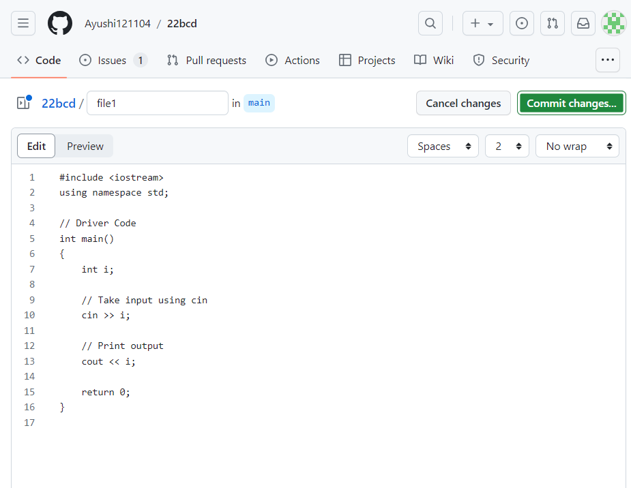

3. After that click on “commit change” , and give commit message and description, then click on Commit Changes.

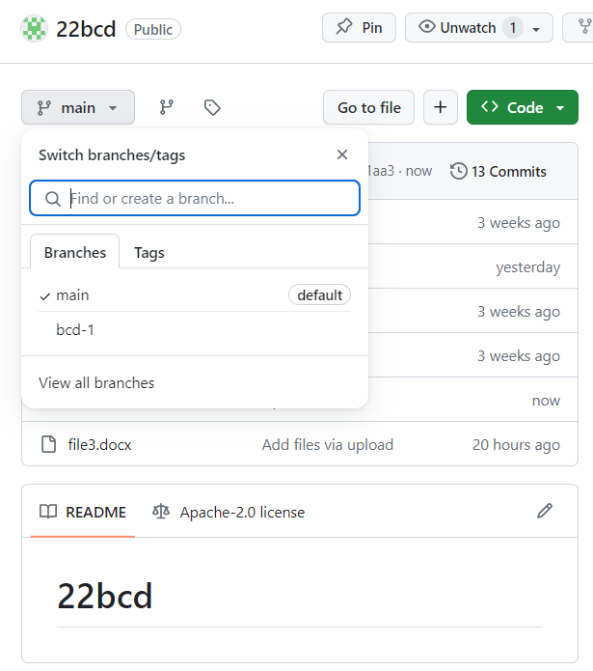

4. Then open the “first file” and click on **“main”** to create branch.

5.In main go on “view all branches” and click on **‘New Branch’** ,then enter the name of branch **‘branching’** and the click on **create new branch.**

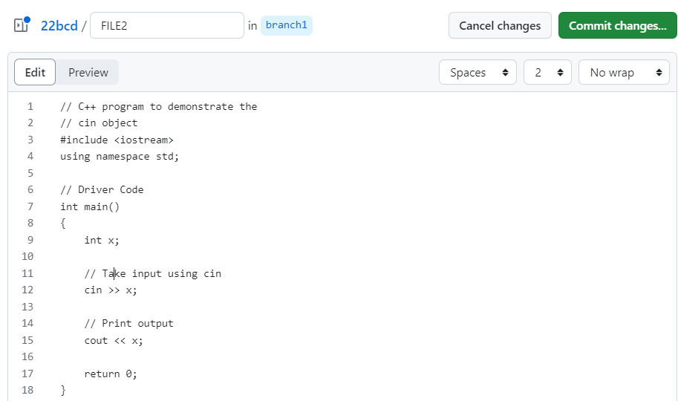

6. Now in the file go on ‘edit the file’ and edit the code.

7. After edit the code then click on **‘commit changes’** to commit the changes , enter commit message and the description.

8. Then in the repository go on “**compare & pull request”.**

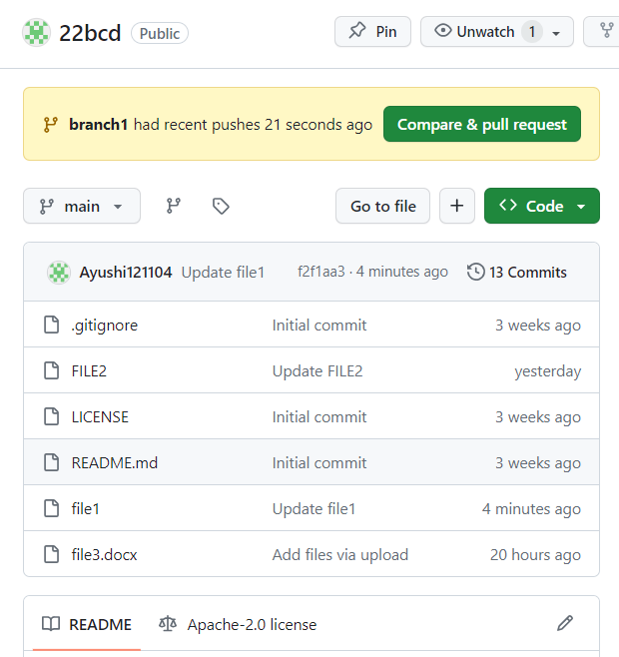

9.Here is the code comparation in split form.

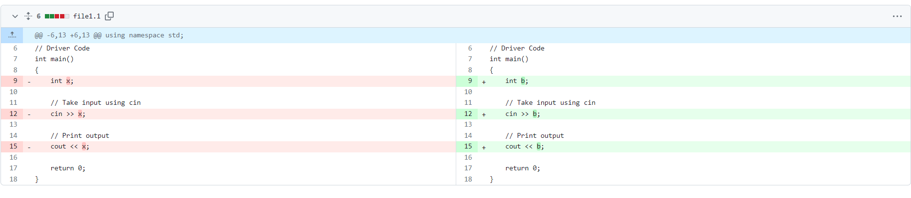

10. Then click on **‘Create pull request’** , and give tittle and description.

11. After this click on **merge pull request**.And **confirm merge.**

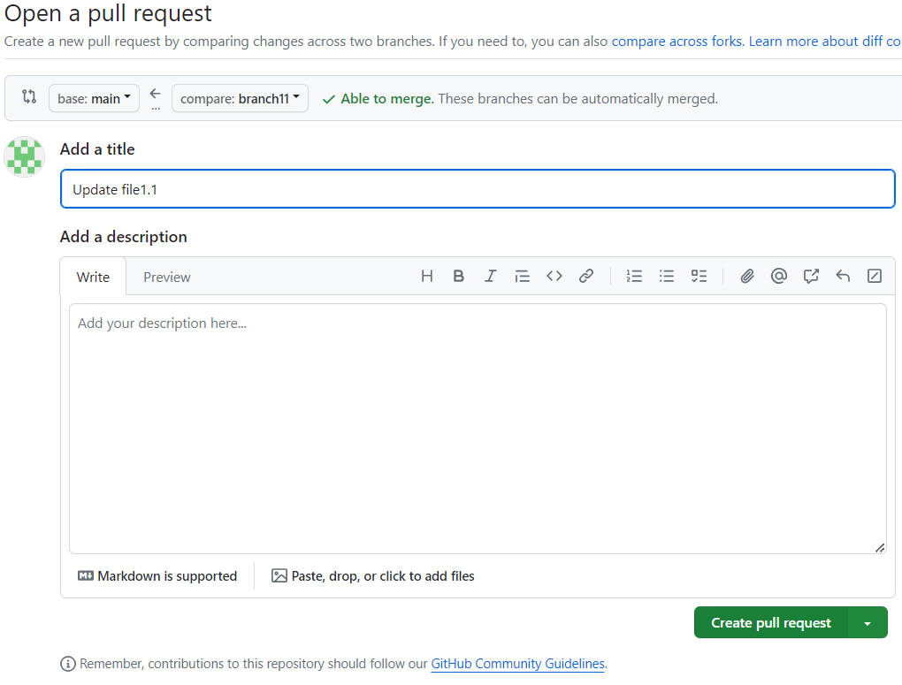

12. If you want to delete the branch so you can delete by clicking on ‘Delete branch’.

**Creating Branch on Git Bash :**

1. First we create a new folder on desktop named ‘git’.
2. After that we initialize it using **‘git init’command.**
3. Then create a new file using command **‘vi ayushi’**.

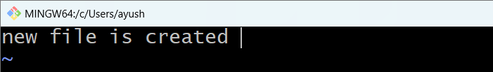

1. Edit the file .

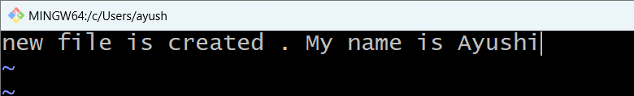

1. Using command **‘git add(ayushi)’** we put it in staging area.
2. Now create a branch using ‘git checkout -b branch_name’ **, git checkout -b newbranch.**

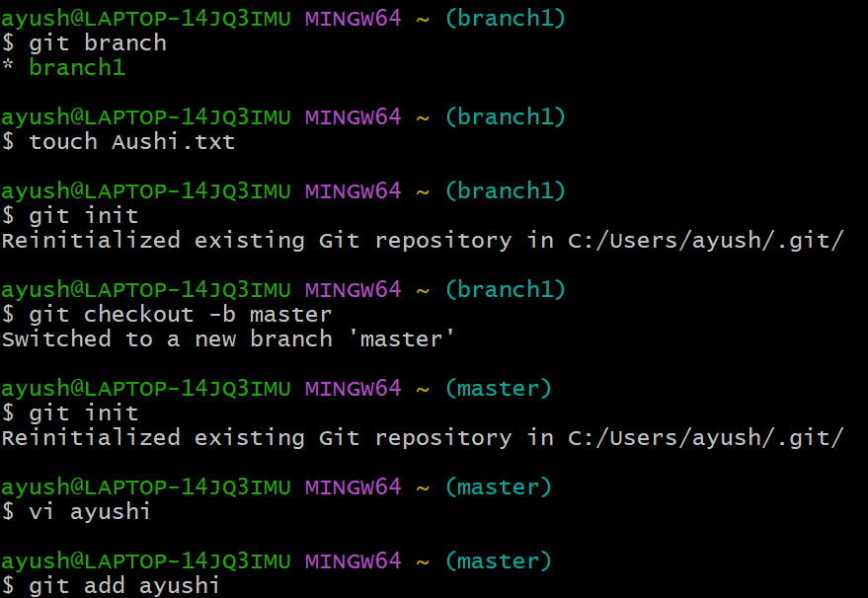

1. Now again edit the file using **‘vi ayushi’.**
2. Using command **‘git add(ayushi)’** we put it in staging area.
3. Commit it using git commit -m “message” .
4. Use “git checkout master ” to move it in a master branch.

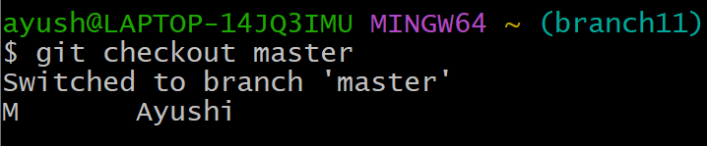

1. Merge branch using ‘git merge new branch’.

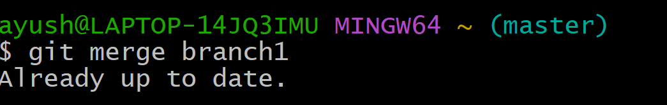

**5. Result/Output/Writing Summary:**

In this experiment we have successfuly created a branch on Github and Gitbash.

**Learning outcomes (What I have learnt):**

**1. .** I have learnt about Branches.

**2.** I have learnt about the process of creating branch on github.

**3.** I have learnt about various commands like ‘**git init’** ‘**git add(file_name)**’ ,‘**git checkout -b branch_name**’, ‘**git commit -m “message**”, “**git checkout master** ”, ‘**git merge newbranch’, ‘git status’**.

**4.** I have learnt about how to add file and merging it.

**5.** I have learnt about **deleting the branch.**

**Evaluation Grid (To be created as per the SOP and Assessment guidelines by the faculty):**

|  |  |  |  |
| --- | --- | --- | --- |
| Sr. No. | Parameters | Marks Obtained | Maximum Marks |
| 1. |  |  |  |
| 2. |  |  |  |
| 3. |  |  |  |
|  |  |  |  |